1. Configure the application-"Payroll" under IIS(sample screen shot below)

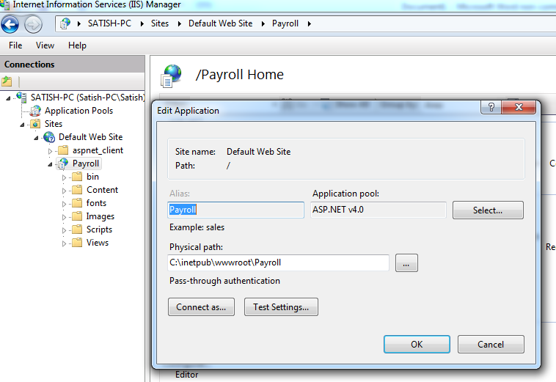

2. Launch Firefox/Chrome, and type the URL - **http://localhost/Payroll** (as per the configured IIS path) on the address bar.

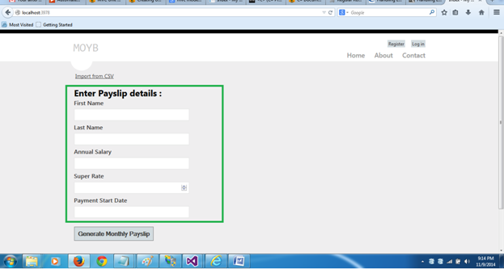

3. The Main screen provides 2 options to view monthly payslip:

* Option 1: By manually entering the details under -"**Enter Payment details**" section(green border) and clicking on Generate Monthly Payslip button.
* Option 2: By clicking on the link "**Import from CSV**"(just above the Enter payment details section). Here, the user can select a CSV file containing Employee data whose monthly pay slip needs to be calculated

4. Option 1: Manual entry -

1. Enter the employee details and click on the Generate Monthly Payslip button.

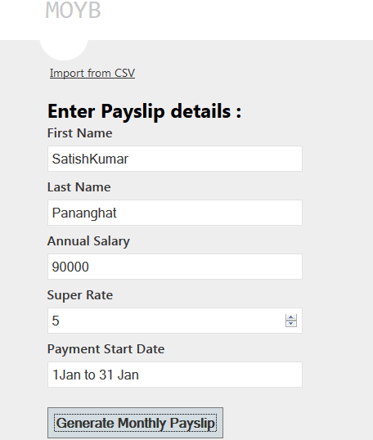

1. The application will calculate the payslip details and the user will be taken to the display screen as below:

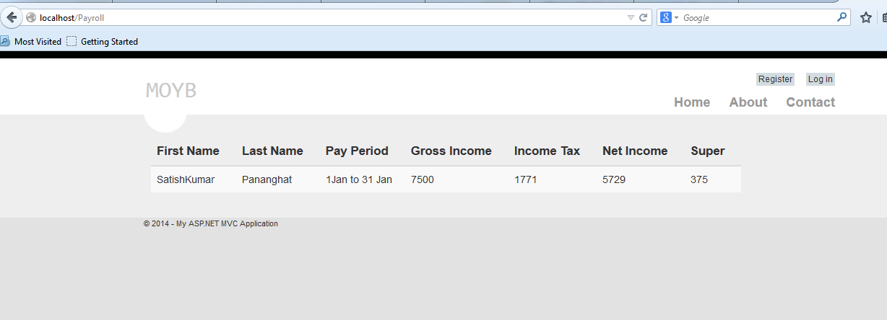

Option 2: Import from CSV:

1. Click on the "Import from CSV" option.
2. Select the input CSV file by browsing to the file location as below and click on "Import". (Sample Input file attached below)



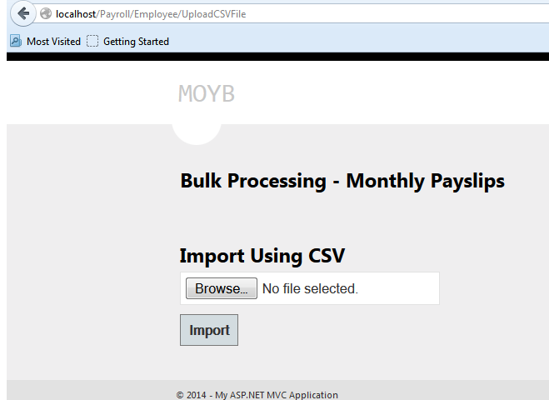

1. Once the user click on the import button, the details are displayed in a grid as follows:

